**Requirements engineer**

+ The requirements engineer leads the effort to **gather and document the architectural drivers**.

+ **help to manage the change and evolution of the architectural drivers** (preferably throughout the system or product life cycle.)

+ The requirements engineer will also serve as the **primary customer liaison(contact),** **united face to the customer.**

<REF> Nothing can be more frustrating to customers than constantly receiving incongruent messages from the organization designing and building their product.

+ The requirements engineer will also **assist the quality engineer** in **coordinating architecture design** review and in defining **“black box”** system or product **tests**.

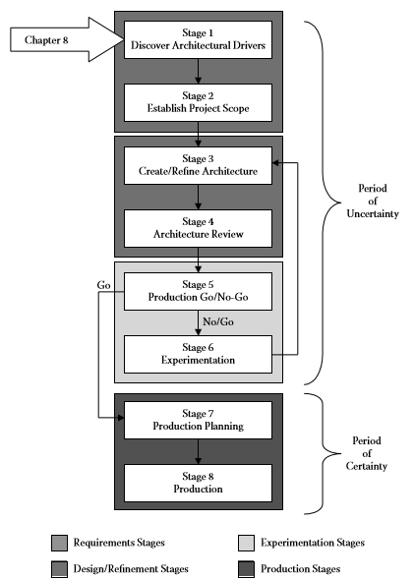

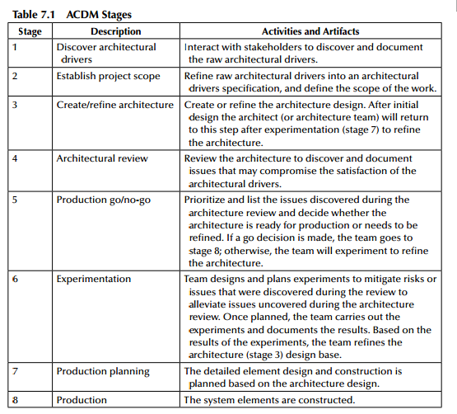

# STAGE 1: discover architectural Drivers

Trong stage 1 🡪 chỉ **tập trung vào collect data** mà thôi chứ không / xác định/cấu trúc hay phân tích architecture drivers

... Tại vì trong thực tế khách hàng không ngồi cùng phân tích được, mà phải càng nhìu càng tốt chứ không hỏi làm ntn? ..

Chủ yếu mình sẽ thu thập những loại yêu cầu sau:

+ high-level functional

+ quality attributes requirements

+ bussiness constraints

+ technical constraints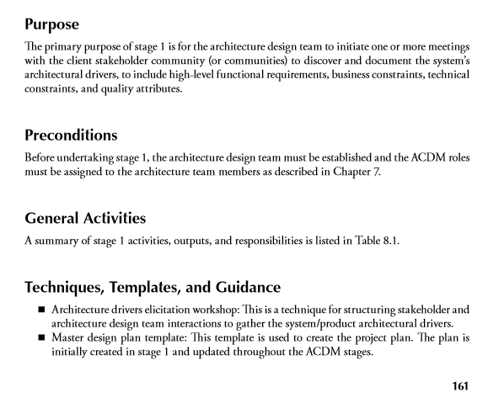

## Roles and Activities, Output and Responsibilities in Stage 1

**Managing enginner:**

Create the initial master design plan

< Master Design Plan: gồm có như chi phí, lịch trình, chiến lược, tatics, dựa trên những ước lượng, giả định ban đầu, lập kế hoạch và dần hoàn thiện kế hoạch.. giải quyết, loại bỏ những cái không chắc chắn, dư thừa --> và sẽ được cập nhật thường xuyên dựa trong các yêu cầu đã làm rõ..>

Assist the requirements engineer in planning the architecture drivers elicitation

Track efforts

Update and replan master design plan based on actual data

**Chief Architect**

Work with the requirements engineer to elicit the requirements from the stakeholders.

Focus on eliciting complete and measureable architecture drivers

Assist the requirements engineering in capturing and documenting to collection of raw architecture drivers.

**Chief scientist**

Work with the requirements engineer to elicit the requirements from the stakeholders.

The chief scientist should focus on technical issues associated with eliciting the architectural drivers. Assist the requirements engineering in capturing and documenting the collection of raw architecture

drivers.

**Requirements Engineer**

Plan, coordinate, and facilitate the stage 1 architectural drivers elicitation workshops.

Coordinate architectural drivers consolidation meetings.

Compile[biên soạn] the consolidated raw architecture drivers document.

**Quality process engineer**

Ensure that the ACDM (and other project processes) are being followed.

Work with the requirements engineer to elicit the requirements from the stakeholders.

Assist the requirements engineering in capturing and documenting the collection of raw architecture drivers.

Coordinate a review of the raw architectural drivers document.

**Support engineer**

Work with the requirements engineer to elicit the requirements from the stakeholders.

Install, configure, and maintain the tools necessary to support stage 1 activities and any tools that can be established now to support the remainder of the project.  
**Production engineers:**

Minimal support is usually required from production engineers.

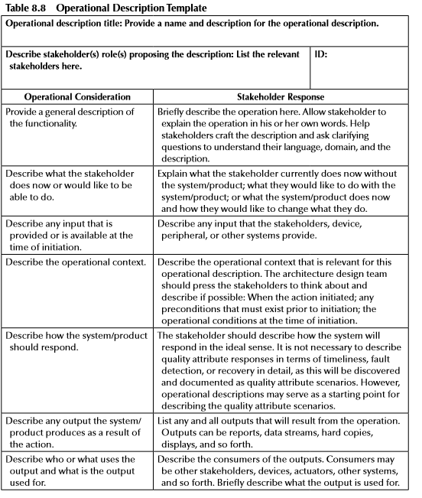

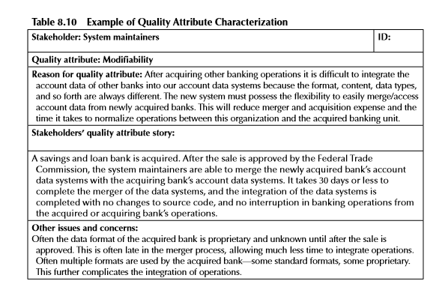

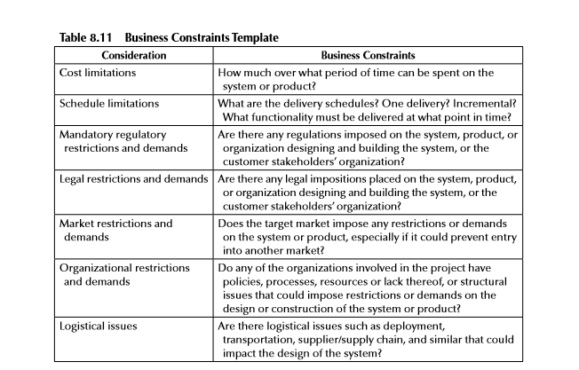

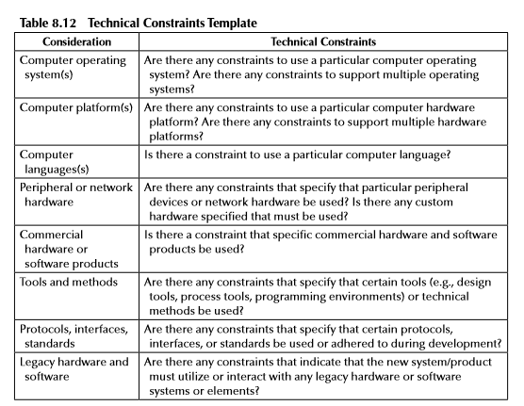

# STAGE 2: Establish Project Scope

Là sẽ refines and analysis architect drivers into an **Architectural Drivers Specification** dựa vào stage 1

Giai đoạn 2 bắt đầu **phân tích** **functional,quality attribute** dựa trên tài liệu operation ( của RE) và xác định các Entities

Xác định Entity bao gồm tất cả những gì tác động vào những gì tác động vào hệ thống của mình thì nó được gọi là entity ( con người, other system, tools ngoài...)

Sử dụng usecase template vào tài liệuThì trong usecase người ta phải có những yếu tố như

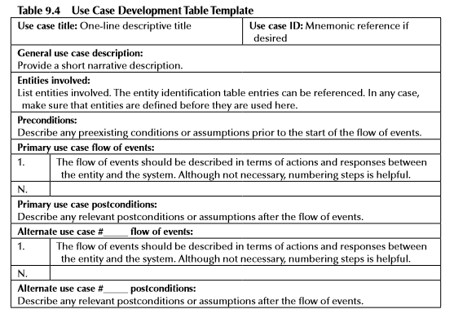

Mẫu phân tích Quality Attributes..

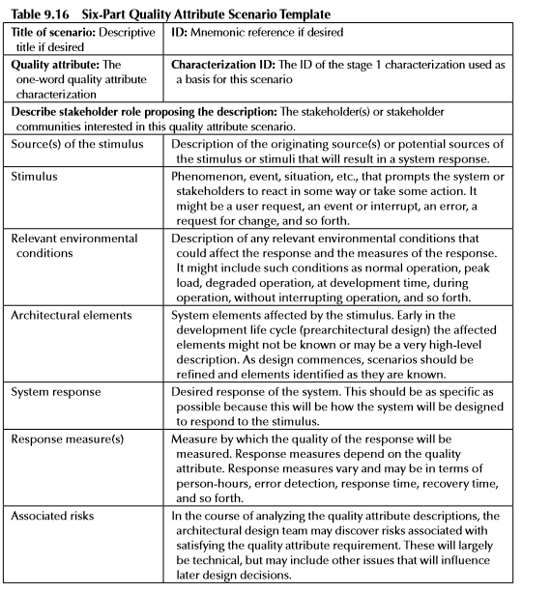

**Đưa ra PIORITY**

* STAGE 2 description
* 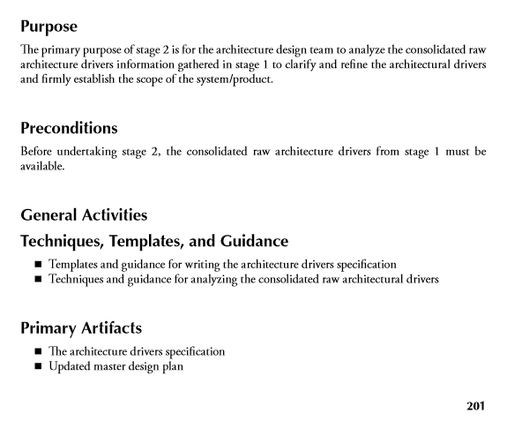

**Managing enginner:**

Plan, coordinate, track, and oversee stage 2 activities.

**Chief Architect**

Lead the analysis of the **consolidated** raw architectural drivers.

**Chief scientist**

Assist in the analysis of the consolidated raw architectural drivers and focus on technical issues, especially **identifying early technical risks** associated with the raw architectural drivers.

**Requirements Engineer**

Responsible for writing the architecture drivers specification document

**Quality process engineer**

Ensure that the ACDM (and other project processes) is being followed, and coordinate a review of the architecture drivers specification document.

**Support engineer**

Assist with analysis of consolidated raw architectural drivers and writing the architecture drivers specification document as necessary.

**Production engineers:**

In stage 2, minimal support is usually required from production engineers. However, they may assist with the analysis of the consolidated raw architectural drivers and writing the architecture drivers specification document as necessary.

Stage 1:

Plan, coordinate, and facilitate the stage 1 architectural drivers elicitation

Coordinate architectural drivers consolidation meetings.

Stage 2:

Responsible for writing the architecture drivers specification document

Stage 3:

Manage requirements change throughout the design

Maintain communications with the stakeholder community.

Assist the chief architect with the design and writing/updating the architecture design document.

Assist quality process engineer with reviews. If required, work with the chief architect to create/update and maintain a **requirements traceability matrix.**

Stage 4:

Participate in the evaluation as a questioner.

Stage 5:

Participate in the issue analysis meetings. the requirements engineer may track the issues raised, map their effect back to the requirements, and track the issues to resolution.

Stage 6:

The requirements engineer will monitor the stakeholder community for changes and breaking developments in the architecture drivers. He or she will also follow the experimentation and the resolution of issues and their impact on satisfying the architecture drivers. Participate in experimentation as a responsible engineer as necessary.

Stage 7:

Assist the managing engineer in conducting the Element-wise Wideband Delphi estimation and in developing the production schedule. The requirements engineer is responsible for planning integrated system/product test.

Stage 8:

The requirements engineer is responsible for conducting/ assisting in integrated system/product test.